

Saveetha Institute of Medical and Technical Sciences Chennai-602105

Design And Development of a Smart Waste Management System with Automated Trash Segregation
A CAPSTONE PROJECT REPORT

Submitted in the partial fulfilment for the Course of

CSA1711 - Artificial Intelligence
to the award of the degree of BACHELOR OF ENGINEERING
Submitted by
T. Charani Kirthi Sri - (192312550)
D. Lokesh - (1923722216)
R. Vishwa Teja - (192372109)

Under the Supervision of
Dr. Krishna Kumar
August -2026



SIMATS ENGINEERING
Saveetha Institute of Medical and Technical Sciences Chennai-602105

DECLARATION

We T. Charani Kirthi Sri -(192312550), D. Lokesh - (192372216), R. Vishwa Teja - (192372109), of the CSE- AI, Saveetha Institute of Medical and Technical Sciences, Saveetha University, Chennai, hereby declare that the Capstone Project Work entitled ‘Design And Development Of A Smart Waste Management System With Automated Trash Segregation’ is the result of our own Bonafide efforts. To the best of our knowledge, the work presented herein is original, accurate, and has been carried out in accordance with principles of engineering ethics.

Place:
Date:

Signature of the Students with Names
T. Charani Kirthi Sri - 192312550
D. Lokesh - 192372216
R. Vishwa Teja - 192372109



SIMATS ENGINEERING
Saveetha Institute of Medical and Technical Sciences Chennai-602105

BONAFIDE CERTIFICATE

This is to certify that the Capstone Project entitled “‘Design and Development of a Smart Waste Management System with Automated Trash Segregation” has been carried out by
T. Charani Kirthi Sri - (192312550), D. Lokesh-(1923722216) and R. Vishwa Teja - (192372109) under the supervision of Ms. Dr. Krishna Kumar and is submitted in partial fulfilment of the requirements for the current semester of the B.E CSE- AI program at Saveetha Institute of Medical and Technical Sciences, Chennai.

SIGNATURE SIGNATURE

Dr. Rashmitha Dr. Krishna Kumar

Program Director Department of CSE

Department of CSE Saveetha School of Engineering

Saveetha School of Engineering SIMATS

SIMATS

Submitted for the Project work Viva-Voce held on .

INTERNAL EXAMINER EXTERNAL EXAMINER

ACKNOWLEDGEMENT

We would like to express our heartfelt gratitude to all those who supported and guided us throughout the successful completion of our Capstone Project. We are deeply thankful to our respected Founder and Chancellor, Dr. N.M. Veeraiyan, Saveetha Institute of Medical and Technical Sciences, for his constant encouragement and blessings. We also express our sincere thanks to our Pro-Chancellor, Dr. Deepak Nallaswamy Veeraiyan, and our Vice-Chancellor, Dr. S. Suresh Kumar, for their visionary leadership and moral support during the course of this project.

We are truly grateful to our Director, Dr. Ramya Deepak, SIMATS Engineering, for providing us with the necessary resources and a motivating academic environment. Our special thanks to our Principal, Dr. B. Ramesh for granting us access to the institute’s facilities and encouraging us throughout the process. We sincerely thank our Head of the

We are especially indebted to our guide, Ms.Dr.Sarannniya and Dr. Dhanalakshmi for their creative suggestions, consistent feedback, and unwavering support during each stage of the project. We also express our gratitude to the Project Coordinators, Review Panel Members (Internal and External), and the entire faculty team for their constructive feedback and valuable inputs that helped improve the quality of our work. Finally, we thank all faculty members, lab technicians, our parents, and friends for their continuous encouragement and support.

Abstract
Improper waste management is one of the major environmental challenges faced by modern cities. Traditional waste disposal methods rely heavily on manual segregation, which is inefficient, time-consuming, and prone to human error. Lack of proper waste classification leads to poor recycling rates, environmental pollution, and increased landfill burden. This project proposes the design of a Smart Waste Management System with Automated Trash Segregation using Object-Oriented Analysis and Design (OOAD) principles to address these issues.

The proposed system introduces an intelligent waste management framework that automatically identifies, segregates, and monitors waste using sensor-based classification and automated control mechanisms. The system models real-world entities such as waste items, sensors, segregation units, monitoring dashboards, and administrators as objects. Object-oriented concepts like encapsulation, abstraction, and modular design are applied to create a structured and scalable architecture. UML diagrams including use case, class, sequence, and activity diagrams are used to represent system behavior and interactions.

The system enhances waste management efficiency by reducing manual intervention, improving recycling accuracy, and enabling real-time monitoring of waste levels. The OOAD-based approach ensures modularity, maintainability, and adaptability for future smart city integration. Overall, the proposed Smart Waste Management System provides an intelligent and sustainable solution for modern waste handling challenges.

Table of contents

S.NO. | CHAPTER | PAGE NO.
1. | INTRODUCTION | 7
2. | PROBLEM IDENTIFICATON & ANALYSIS | 10
3. | SOLUTION DESIGN & IMPLEMENTATION | 12
4. | RESULT & RECOMMENDATIONS | 15
5. | REFLECTION ON LEARNING AND PERSONAL  DEVELOPMENT | 17
6. | CONCLUSION | 21
7. | REFERENCES | 23

CHAPTER 1: INTRODUCTION

Background Information

Waste management is a critical component of sustainable urban development. Rapid urbanization and population growth have significantly increased waste generation, placing pressure on municipal waste management systems. Traditional waste disposal methods often involve manual sorting, open dumping, and inefficient recycling practices, leading to environmental pollution and health risks.

With advancements in automation and IoT technologies, smart waste management solutions are emerging as efficient alternatives. Automated waste segregation systems can identify waste types and separate them without human involvement. However, many existing solutions lack structured system design, making them difficult to scale or maintain. This highlights the need for an Object-Oriented Analysis and Design approach to create a modular and efficient waste management framework.

Project Objectives

The primary objective of this project is to design a Smart Waste Management System with Automated Trash Segregation using Object-Oriented Analysis and Design (OOAD) principles. The system aims to create a structured and intelligent framework that can automatically identify and segregate waste into categories such as biodegradable, recyclable, and non-recyclable materials. By modeling real-world components such as sensors, waste bins, segregation units, and monitoring systems as software objects, the project focuses on demonstrating clarity, modularity, and logical consistency in system design. The objective is not only to improve waste segregation efficiency but also to showcase how object-oriented concepts can be applied to build scalable and maintainable smart environmental solutions.

Another key objective of the project is to strengthen the practical understanding of OOAD concepts such as abstraction, encapsulation, modular decomposition, and UML-based system modeling. The project emphasizes designing a flexible architecture that supports future enhancements like IoT integration, AI-based waste recognition, and smart city connectivity. Additionally, it aims to highlight the importance of sustainable technology by promoting automation in waste management, reducing human intervention, and improving environmental hygiene.

Significance

The significance of this project lies in addressing environmental and sustainability challenges through intelligent automation. Improper waste segregation leads to contamination of recyclable materials and increased landfill usage. By introducing an automated and structured system, waste can be processed more efficiently and safely.

From a software engineering perspective, the project demonstrates the practical application of OOAD in designing real-world IoT-based systems. It helps students understand how object-oriented principles can be applied to environmental and smart city domains.

Scope

The scope of this project focuses on the analysis and design of a Smart Waste Management System with Automated Trash Segregation using Object-Oriented Analysis and Design (OOAD) principles. The project primarily covers conceptual modeling of the system, including waste detection, automated segregation, monitoring, and administrative control. It involves identifying system actors, defining functional modules, and representing system behavior through UML diagrams such as use case, class, sequence, and activity diagrams. The design models real-world components like smart bins, sensors, segregation units, and monitoring dashboards as objects with clearly defined responsibilities and interactions.

The project scope is limited to system design and architectural modeling rather than full-scale hardware implementation or deployment. While the system concept supports technologies like IoT sensors, automation mechanisms, and smart monitoring platforms, their implementation is considered outside the immediate scope. However, the design provides a strong foundation for future enhancements such as AI-based waste recognition, real-time IoT integration, and smart city deployment. By focusing on structured analysis and design, the project ensures academic relevance while maintaining flexibility for real-world expansion and implementation.

Methodology Overview

The methodology adopted for this project follows a structured Object-Oriented Analysis and Design (OOAD) approach to ensure clarity, modularity, and systematic development of the Smart Waste Management System with Automated Trash Segregation. The process begins with requirement analysis, where the problem domain is studied and key system functionalities are identified. Stakeholders such as users, municipal authorities, and administrators are analyzed to determine system expectations and interaction.

CHAPTER 2: PROBLEM IDENTIFICATION AND ANALYSIS

2.1Description of the Problem

Improper waste management has become a major environmental and public health concern, especially in rapidly urbanizing areas. Most existing waste disposal systems rely heavily on manual segregation, where sanitation workers sort waste into different categories. This process is not only time-consuming and inefficient but also exposes workers to harmful substances and health risks. Additionally, manual sorting often leads to incorrect segregation, causing recyclable materials to be mixed with organic or hazardous waste. As a result, recycling efficiency decreases, landfill usage increases, and environmental pollution becomes more severe.

Another significant issue is the lack of real-time monitoring and intelligent waste handling mechanisms in traditional systems. Garbage bins often overflow due to irregular collection schedules and absence of monitoring systems, leading to unhygienic surroundings and spread of diseases. Municipal authorities also face challenges in optimizing waste collection routes and resource allocation due to insufficient data. These limitations highlight the need for an automated and intelligent waste management solution that can accurately segregate waste and provide real-time monitoring. A smart, object-oriented system can address these challenges by introducing automation, improving efficiency, and ensuring sustainable waste management practices.

Evidence of the Problem

Numerous studies and real-world observations highlight the inefficiencies of traditional waste management systems. Reports from urban municipalities indicate that a large percentage of waste generated in cities is not properly segregated at the source, resulting in recyclable materials being contaminated and sent to landfills. Environmental studies show that improper waste segregation significantly reduces recycling efficiency and increases environmental pollution. Overflowing garbage bins are a common sight in many urban areas, demonstrating the lack of real-time monitoring and effective waste collection strategies. These issues contribute to air, water, and soil pollution, ultimately affecting public health and environmental sustainability.

Stakeholders

The Smart Waste Management System with Automated Trash Segregation involves multiple stakeholders who play a vital role in its design, implementation, and operation. The primary stakeholders include citizens or users who interact directly with smart bins by disposing of waste. Municipal authorities and waste management departments are also key stakeholders, as they are responsible for overseeing waste collection, monitoring system performance, and ensuring proper disposal and recycling. Sanitation workers benefit from the system by experiencing reduced exposure to hazardous waste and improved working conditions due to minimized manual segregation.
Secondary stakeholders include recycling industries and environmental agencies that rely on properly segregated waste for efficient recycling and sustainability initiatives. Smart city planners and government bodies are also important stakeholders, as they use such systems to promote eco-friendly infrastructure and urban development. Additionally, software developers and system designers are stakeholders responsible for building and maintaining the system architecture using object-oriented principles. The involvement of diverse stakeholders highlights the need for a structured and scalable design that ensures efficiency, safety, and environmental sustainability.

Supporting Data / Research

Various environmental and urban development studies emphasize the importance of proper waste segregation for sustainable waste management. Research indicates that a significant portion of municipal solid waste can be recycled if segregated correctly at the source. However, improper segregation leads to contamination of recyclable materials, reducing their usability and increasing landfill dependency. Studies conducted in smart city initiatives show that automated waste segregation and sensor-based monitoring systems can significantly improve recycling rates and reduce environmental pollution. These findings support the need for intelligent waste management solutions that incorporate automation and real-time monitoring.

From a technological perspective, research in IoT and smart infrastructure highlights the effectiveness of automation in improving waste handling efficiency. IoT-enabled waste monitoring systems provide real-time data on bin fill levels, enabling optimized waste collection routes and reduced operational costs. Additionally, software engineering research supports the use of Object-Oriented Analysis and Design (OOAD) for modeling complex systems due to its modularity, scalability, and maintainability. Academic literature demonstrates that UML-based system modeling enhances clarity in system design.

CHAPTER 3: SOLUTION DESIGN AND IMPLEMENTATION

Development and Design Process

The development and design of the Smart Waste Management System with Automated Trash Segregation follow a structured Object-Oriented Analysis and Design (OOAD) methodology. The process begins with requirement analysis, where the problem domain is carefully studied to identify system goals, stakeholders, and functional requirements. Key components such as smart bins, sensors, segregation mechanisms, monitoring modules, and administrative controls are identified based on real-world waste management workflows. These components are then conceptualized as objects with clearly defined responsibilities, ensuring a logical mapping between real-world entities and software models.

Following requirement identification, the system is decomposed into modular components to enhance clarity and scalability. Major modules include waste detection, classification, automated segregation, monitoring dashboard, and administrative management. UML diagrams such as use case, class, sequence, and activity diagrams are developed to represent system structure and behavior. This iterative design approach ensures consistency across all system models and supports refinement at each stage. By emphasizing modularity and object interaction, the development process creates a flexible architecture that can easily accommodate future enhancements such as IoT deployment, AI-based waste recognition, and integration with smart city infrastructure.

Tools and Technologies Used

The Smart Waste Management System with Automated Trash Segregation is designed using standard tools and technologies that support Object-Oriented Analysis and Design (OOAD) and UML-based modeling. UML modeling tools such as Umbrello, StarUML, or Visual Paradigm are used to create essential system diagrams including use case, class, sequence, and activity diagrams. These tools help visually represent system structure, object relationships, and workflows, ensuring clarity and consistency throughout the design process. The use of standardized UML notation improves documentation quality and makes the system easier to understand and maintain.

Solution Overview

The Smart Waste Management System with Automated Trash Segregation provides an intelligent and structured approach to handling waste using automation and object-oriented system design. The system allows users to dispose of waste into a smart bin equipped with sensors that analyze the physical properties of the waste. Based on characteristics such as moisture, metal content, or material type, the system automatically classifies the waste into categories like biodegradable, recyclable, or non-recyclable. Once identified, an automated segregation mechanism directs the waste into appropriate compartments, reducing the need for manual sorting and minimizing human error.

In addition to automated segregation, the system includes a monitoring and control module that enables administrators or municipal authorities to track bin status and system performance. Data such as bin fill levels and segregation statistics can be monitored through a centralized dashboard, enabling efficient waste collection planning and resource optimization. The object-oriented architecture ensures seamless interaction between hardware components and software modules, making the system modular and scalable

Ethical Standards Applied

Ethical considerations play an important role in the design of the Smart Waste Management System with Automated Trash Segregation. The system promotes environmental responsibility by encouraging proper waste segregation and reducing pollution caused by improper disposal. By automating waste handling, the design minimizes direct human contact with hazardous materials, thereby improving the safety and health conditions of sanitation workers. The system also supports sustainable practices by enabling efficient recycling and reducing landfill dependency, aligning with global environmental protection standards.

Solution Justification

The justification for developing a Smart Waste Management System with Automated Trash Segregation lies in the growing limitations of traditional waste management practices. Manual segregation methods are inefficient, labor-intensive, and prone to errors, often resulting in improper disposal and reduced recycling efficiency. Additionally, the lack of real-time monitoring and structured waste handling systems leads to overflowing bins, environmental pollution, and increased operational costs for municipal authorities. These challenges highlight the need for an automated and intelligent solution that can improve waste segregation accuracy while ensuring safer and more hygienic waste handling processes.

CHAPTER 4: RESULTS AND RECOMMENDATIONS

  - Evaluation of Results

The evaluation of the Smart Waste Management System with Automated Trash Segregation is based on the effectiveness of its object-oriented design and system modeling. The UML diagrams developed for the system clearly represent both structural and behavioral aspects, demonstrating proper application of OOAD principles such as encapsulation, modularity, and abstraction. The use case diagram effectively captures interactions between users, administrators, and the system, while the class diagram defines clear relationships among system components like sensors, bins, segregation units, and monitoring modules. Sequence and activity diagrams illustrate logical workflows for waste detection, classification, and segregation, ensuring conceptual clarity and real-world relevance.

In addition to design accuracy, the system demonstrates strong potential for practical implementation. The automated segregation workflow reduces reliance on manual sorting and improves waste classification efficiency. The modular architecture ensures scalability and ease of integration with future technologies such as IoT deployment and smart monitoring platforms. Overall, the design achieves its intended objectives by providing a clear, structured, and extensible framework for intelligent waste management. The results indicate that the proposed system is conceptually sound, environmentally beneficial, and suitable for further development into a real-world smart waste solution.

Challenges Encountered

During the design of the Smart Waste Management System with Automated Trash Segregation, several challenges were encountered while applying Object-Oriented Analysis and Design principles to a hardware-integrated problem domain. One major challenge was accurately modeling real-world sensor-based interactions within UML diagrams. Representing how sensors detect different types of waste and trigger automated segregation required careful abstraction to ensure that the system remained conceptually clear while still reflecting real-world functionality. Balancing technical accuracy with diagram simplicity was essential to maintain clarity in system representation.

Another challenge involved maintaining consistency across different UML diagrams. Ensuring that use cases, class relationships, and sequence interactions aligned logically required multiple iterations and refinements. Additionally, designing a modular architecture that accommodates both software logic and potential hardware integration was complex, as it

required anticipating future implementation constraints without overcomplicating the design. These challenges were addressed through iterative analysis, continuous refinement of models, and adherence to OOAD principles, resulting in a well-structured and coherent system design.

Possible Improvements

Although the current design of the Smart Waste Management System with Automated Trash Segregation provides a strong conceptual framework, several improvements can enhance its functionality and real-world applicability. One key improvement is the integration of advanced artificial intelligence techniques, such as computer vision-based waste recognition, to improve segregation accuracy. Implementing AI models can enable the system to identify complex waste types more effectively than basic sensor-based classification. Additionally, incorporating IoT connectivity can allow real-time monitoring of bin status, enabling smarter waste collection scheduling and reducing operational inefficiencies.

Further improvements can include the development of a user-friendly mobile or web application for monitoring and control, allowing administrators to track system performance remotely. The system can also be enhanced with solar-powered smart bins to improve energy efficiency and sustainability. Advanced data analytics and predictive algorithms can help forecast waste generation patterns, supporting better planning and resource optimization. Integration with smart city infrastructure and recycling management systems would further extend the system’s impact, making it a comprehensive and intelligent solution for modern urban waste management.

Recommendations

It is recommended that the Smart Waste Management System with Automated Trash Segregation be further developed into a fully functional prototype to validate its practical feasibility. Implementing the system using IoT hardware such as microcontrollers, sensors, and automated segregation mechanisms can help evaluate real-time performance and reliability. Pilot deployment in controlled environments such as educational campuses, residential communities, or corporate complexes can provide valuable insights into system efficiency, user interaction, and operational challenges. Feedback from stakeholders such as municipal authorities and sanitation workers should be incorporated to refine system functionality and usability.

CHAPTER 5: REFLECTION ON LEARNING AND PERSONAL DEVELOPMENT

Key Learning Outcomes

The development of the Smart Waste Management System with Automated Trash Segregation provided valuable learning outcomes in both academic and practical aspects of software engineering. One of the primary learnings was the effective application of Object-Oriented Analysis and Design (OOAD) principles to a real-world environmental problem. The project demonstrated how abstract concepts such as encapsulation, abstraction, modularity, and object interaction can be applied to design structured and scalable systems. Through the creation of UML diagrams, the ability to visualize complex workflows and system relationships was significantly improved.

Additionally, the project enhanced analytical thinking and problem-solving skills by requiring the translation of real-world waste management challenges into software design models. It strengthened understanding of how systematic analysis and structured design can simplify complex systems and improve clarity. The experience also emphasized the importance of sustainability-driven technology and responsible engineering practices. Overall, the project contributed to a deeper understanding of system modeling, improved design documentation skills, and increased confidence in applying theoretical OOAD concepts to practical, real-life applications.

Academic Knowledge

This project significantly strengthened academic understanding of Object-Oriented Analysis and Design (OOAD) concepts by applying theoretical principles to a real-world problem domain. Core concepts such as abstraction, encapsulation, inheritance, and modularity were reinforced through the structured modeling of system components like smart bins, sensors, segregation modules, and monitoring dashboards. The use of UML diagrams—including use case, class, sequence, and activity diagrams—enhanced comprehension of how abstract design ideas can be visually represented to describe both static structure and dynamic behavior of a system.

Furthermore, the project bridged the gap between classroom learning and practical application by demonstrating how software engineering methodologies are used in system design. It

15

deepened knowledge of requirement analysis, system decomposition, and architectural planning, all of which are essential academic foundations in OOAD.

Technical Skills

This project contributed significantly to the development of technical skills related to system modeling and structured software design. One of the key skills gained was proficiency in creating UML diagrams such as use case, class, sequence, and activity diagrams. Working with these diagrams improved the ability to visually represent system architecture, object relationships, and workflow processes in a clear and organized manner. The project also enhanced understanding of how to break down complex real-world problems into manageable modules using object-oriented design principles.

Problem-Solving and Critical Thinking

This project played an important role in enhancing problem-solving and critical thinking abilities by requiring a structured approach to addressing real-world waste management challenges. Designing an automated trash segregation system involved analyzing complex environmental issues and translating them into logical software models. Identifying system actors, defining object responsibilities, and mapping interactions demanded careful evaluation and decision-making. The process of selecting appropriate design strategies and organizing system modules improved the ability to approach problems systematically and logically.

Additionally, the project encouraged critical thinking through continuous analysis and refinement of design models. Challenges such as representing sensor-based automation in UML diagrams and maintaining consistency across system components required thoughtful revisions and iterative improvements.

5.1 Challenges Encountered and Overcome
Throughout the development of the Smart Waste Management System with Automated Trash Segregation, several challenges were encountered during the analysis and design phases. One of the primary challenges was accurately modeling a system that combines both software logic and hardware interaction. Representing sensor-based automation and segregation mechanisms within UML diagrams required careful abstraction to ensure that real-world functionality was reflected without making the models overly complex. Maintaining clarity while capturing the dynamic behavior of the system posed additional difficulty, especially when aligning multiple diagrams such as use case, class, and sequence models.
16

Another significant challenge was ensuring consistency and modularity across the entire system design. Each component needed to be logically connected while still maintaining clear separation of responsibilities. Balancing simplicity and completeness in the design required multiple iterations and refinements. These challenges were overcome through iterative analysis, continuous diagram refinement, and adherence to Object-Oriented Analysis and Design principles. Regular evaluation of system structure and workflows helped improve clarity and coherence, ultimately resulting in a well-structured and scalable system design.

Personal and Professional Growth
Working on the Smart Waste Management System with Automated Trash Segregation contributed significantly to personal and professional development. The project improved time management and organizational skills, as it required planning, structured documentation, and systematic completion of multiple design stages. Handling a real-world problem domain helped build confidence in approaching complex engineering challenges independently. The experience also fostered discipline and attention to detail, particularly while creating consistent UML diagrams and maintaining clarity in technical documentation.

Collaboration and Communication

The development of the Smart Waste Management System with Automated Trash Segregation enhanced collaboration and communication skills throughout the project lifecycle. Even when working individually or in small teams, the project required continuous discussion of ideas, clarification of design concepts, and exchange of feedback. Explaining system architecture, UML diagrams, and design decisions helped improve the ability to communicate technical concepts clearly and effectively. This experience emphasized the importance of teamwork in software engineering, where collective understanding and shared responsibility contribute to better system design.

Insights into the Industry
The development of the Smart Waste Management System with Automated Trash Segregation provided valuable insights into how modern industries are increasingly adopting smart and
sustainable technologies. Waste management has evolved from traditional manual processes to intelligent, data-driven systems that integrate automation, IoT, and analytics. The project highlighted how industries are moving toward smart city solutions where efficient resource utilization, environmental sustainability, and real-time monitoring play a critical role.
Understanding this shift provided a clearer perspective on how software engineering contributes to solving large-scale urban and environmental challenges.

17

CHAPTER 6: CONCLUSION

Conclusion

The Smart Waste Management System with Automated Trash Segregation demonstrates how structured software design principles can be effectively applied to address real-world environmental challenges. By utilizing Object-Oriented Analysis and Design (OOAD) methodologies, the project successfully models waste management processes into a modular and scalable system architecture. Through the use of UML diagrams, the system clearly represents interactions between users, smart bins, sensors, and monitoring modules, ensuring clarity in both structural and behavioral aspects of the design. This structured approach highlights the importance of proper analysis and design in building efficient and sustainable smart systems.The project emphasizes the potential of automation and intelligent system design in improving waste segregation efficiency and reducing reliance on manual processes. By introducing automated classification and monitoring mechanisms, the proposed system supports better recycling practices and promotes environmental sustainability. The modular architecture ensures flexibility, allowing future integration with advanced technologies such as IoT, artificial intelligence, and smart city platforms. Overall, the project serves as a strong example of how object-oriented design can be leveraged to create innovative and impactful solutions for modern societal issues. It reinforces the importance of combining technical expertise with sustainability-driven thinking in engineering practice.

Future Scope

The Smart Waste Management System with Automated Trash Segregation offers significant scope for future enhancements and real-world implementation. One major extension of this project is the development of a fully functional prototype using IoT hardware such as microcontrollers, sensors, and automated segregation mechanisms. Real-time deployment in environments like campuses, residential communities, and public spaces would help validate system efficiency and reliability. Implementing cloud connectivity for live monitoring and data storage can further enhance system usability and enable centralized waste management. Future advancements can also include the integration of artificial intelligence and machine learning techniques to improve waste classification accuracy. Computer vision models can be trained to identify complex waste types using image recognition, making the system more intelligent and adaptive. Additionally, predictive analytics can be incorporated to forecast waste generation patterns, allowing authorities to optimize waste collection schedules and resource allocation.
18

REFERENCES

- 1.Pressman, R. S., Software Engineering: A Practitioner’s Approach, McGraw-Hill Education, 7th Edition.
- 2.Bruegge, B., and Dutoit, A. H., Object-Oriented Software Engineering Using UML, Patterns, and Java, Pearson Education.
- 3.Lethbridge, T. C., and Laganière, R., Object-Oriented Software Engineering: Practical Software Development Using UML and Java, McGraw-Hill.
- 4.Swain, G., Object-Oriented Analysis and Design Through Unified Modeling Language, Laxmi Publications, 2010.
- Jain, A., Software Engineering with UML, Vision Publications.
- 5.Stevens, P., and Pooley, R., Using UML: Software Engineering with Objects and Components, Addison-Wesley.
- 6.Mellor, S. J., and Balcer, M., Executable UML: A Foundation for Model-Driven Architecture, Addison-Wesley.
- Ghezzi, C., Jazayeri, M., and Mandrioli, D., Fundamentals of Software Engineering, Prentice Hall.
- 7.World Bank, What a Waste 2.0: A Global Snapshot of Solid Waste Management, World Bank Publications.
- 8.Kumar, S., et al., “Smart Waste Management Using IoT: A Review,” International Journal of Engineering Research & Technology (IJERT).

APPENDICES
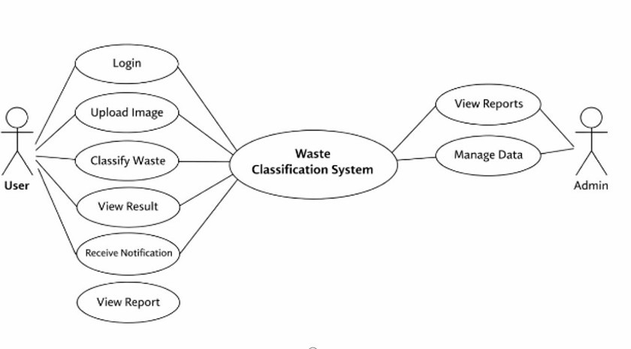

Fig 1 – Use Case Diagram (AI)
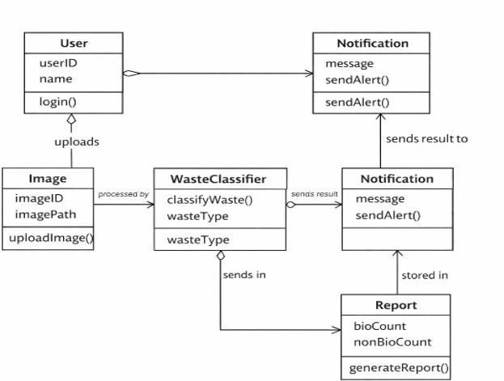

Fig 2 – Class Diagram (AI)

20

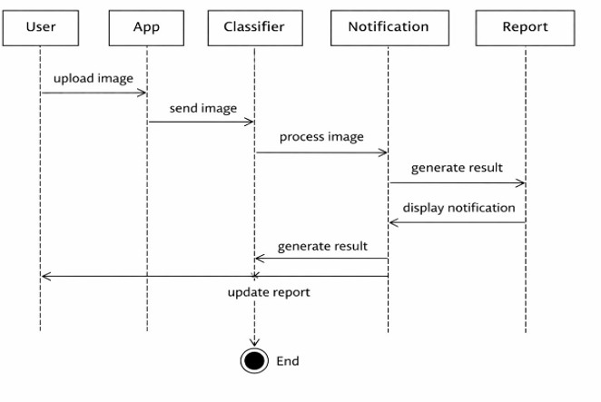

Fig 3 – Sequence Diagram (AI)

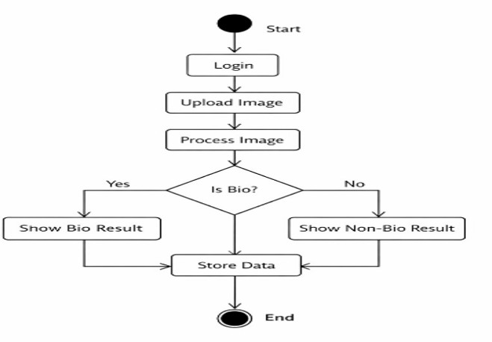

Fig – 4 Activity Diagram (AI)

21

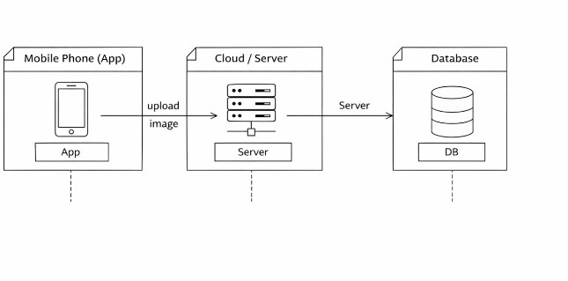

Fig – 5 Deployment Diagram (AI)
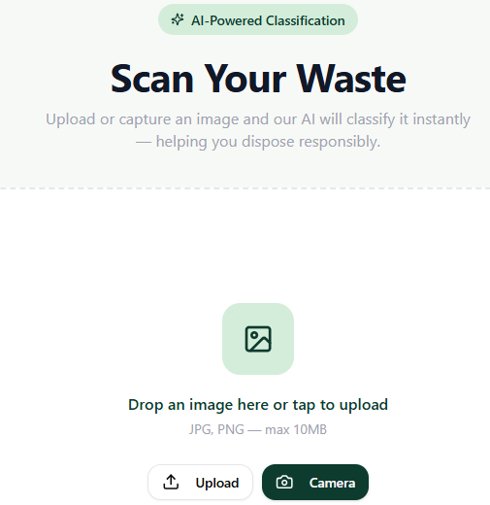

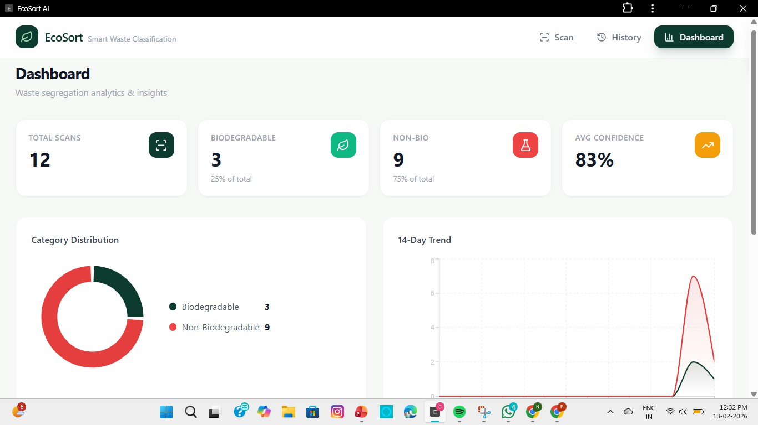

Fig 6. Software Output

22

23

